**Q. 1 To be drawn using isometric dimensions, and accordingly the dimensioning should be done.**

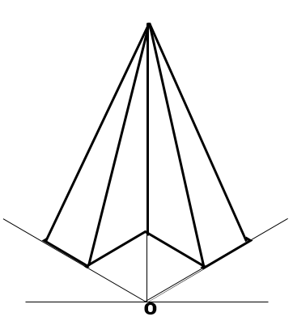

**Q. 2 To be drawn using true dimensions, and accordingly the dimensions should be provided.**

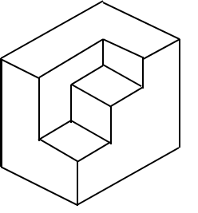

**Q.3 To be drawn using true dimensions, and accordingly the dimensions should be provided.**

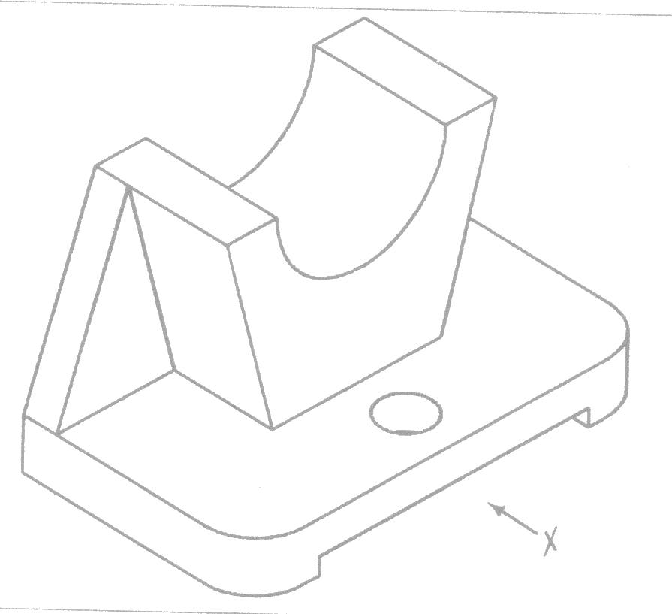

**Q.4 To be drawn using true dimensions, and accordingly the dimensions should be provided.**

